Using toString( ) of Throwable Class

***toString( )***when used with exception (i.e. object) prints the System Defined Message with basic details.

Syntax -  ***exception*.toString( )**

But, the following two statements gives the same out when used in catch block and an exception is handled -

1. System.out.println(exception);
2. System.out.println(exception.toString( ));

Output for the above two statement is same -

java.language.ArithmeticException: /by zero

Lets implement this on Eclipse IDE -

1. Launch Eclipse IDE, write the below statement in the catch block of 'PrintExceptions.java' Class of  the existing project as shown below -

[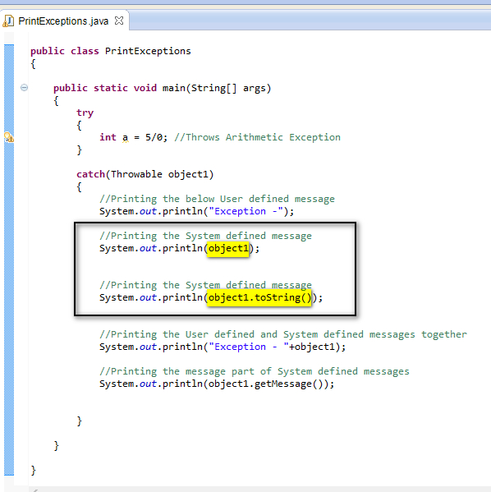](https://1.bp.blogspot.com/-OkseNkFw-ZE/U-84xb82ZWI/AAAAAAAAb2Y/YprFgNTWsbg/s1600/13.jpg)

2. Save and Run the Java Class 'PrintExceptions.java' and observe that the above thrown arithmetic exception is handled by printing the following in the output -

[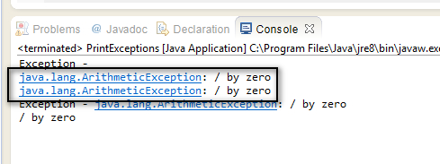](https://3.bp.blogspot.com/-Z5YnN8fnx3U/U-87uyA3kPI/AAAAAAAAb2k/nhEr5ENl7gM/s1600/14.jpg)

Hence printing the exception directly or by using the exception.toString( ) will give the same output as shown above . Basic details of the exception i.e. exception name and its cause are displayed.